Kumite
There are several forms of kumite (sparring) in the Shotokan system.

Ippon kumite | One-step sparring | Typically used for self defense drills
Sanbon kumite | Three-step sparring | Typically used to develop speed, strength, and technique
Kiso kumite | Structured sparring,  drawn from a kata | Typically used to develop understanding of the applications of the kata, or bunkai
Jiyu kumite | Free sparring | Either one-step (Jiyu Ippon kumite), for training, or completely free "point" sparring
Traditional Kumite
(The following passages were taken from the Wikipedia article on Shotokan.)
Kumite, or sparring (literal "partner exercise"), is the practical application of kata to real opponents. While the techniques used in sparring are only slightly different than kihon, the formalities of kumite in Shotokan karate were first instituted by Masatoshi Nakayama wherein basic, intermediate, and advanced sparring techniques and rules were formalized. (Kanazawa Sensei extended these further.)
Shotokan practitioners first learn how to apply the techniques taught in kata to "hypothetical" opponents by way of kata bunkai. Kata bunkai then matures into controlled kumite.
Kumite is the third part of the Shotokan triumvirate of Kihon-Kata-Kumite. Kumite is taught in ever increasing complexity from beginner through low grade blackbelt (1st - 2nd) to intermediate (3rd - 4th) and advanced (5th onwards) level practitioners.
Beginners first learn kumite through basic drills, of 1, 3 or 5 attacks to the head or body with the defender stepping backwards whilst blocking and only countering on the last defence. These drills use basic techniques and develop a sense of timing and distance in defence against a known attack.
At around purple belt level karateka learn one-step sparring (ippon kumite). Though there is only one step involved, rather than three or five, this exercise is more advanced because it involves a greater variety of blocks and counter-attacks, usually of the defender's own choice. It also requires the defender to execute a counter-attack faster than in the earlier types of sparring. Counter-attacks may be almost anything, including strikes, grapples, and take-down manuvers.
Some schools prescribe the defences, most notable the Kase-ha Shotokan-ryu which uses an 8 step, three directional blocking and attacking pattern which develops from yellow belt level right through to advanced level.
The next level of kumite is freestyle one-step sparring (jiyu ippon kumite). This type of kumite, and its successor – free sparring – have been documented extensively by Nakayama and Kanazawa and are expanded upon by the JKA instructor trainee program, for those clubs under the JKA. Freestyle one-step sparring is similar to one-step sparring but requires the karateka to be in motion. Practicing one-step sparring improves free sparring (jiyu kumite) skills, and also provides an opportunity for practicing major counter-attacks (as opposed to minor counter-attacks). Tsutomu Ohshima states that freestyle one-step sparring is the most realistic practice in Shotokan karate, and that it is more realistic than free sparring.
Free sparring (jiyu kumite) is the last element of sparring to be learned. In this exercise, two training partners are free to use any karate technique or combination of attacks, and the defender at any given moment is free to avoid, block, counter, or attack with any karate technique. Training partners are encouraged to make controlled and focused contact with their opponent, but to withdraw their attack as soon as surface contact has been made. This allows a full range of target areas to be attacked (including punches and kicks to the face, head, throat, and body) with no padding or protective gloves, but maintains a degree of safety for the participants. Throwing one's partner and performing takedowns are permitted in free sparring, however it is unusual for competition matches to involve extended grappling or ground-wrestling, as Shotokan karateka are encouraged to end an encounter with a single attack, avoiding extended periods of conflict or unnecessary contact.
Kaishu ippon kumite is an additional sparring exercise that is usually introduced for higher grades. This starts in a similar manner to freestyle one-step sparring; the attacker names the attack he/she will execute, attacks with that technique, and the defender blocks and counters the attack. Unlike freestyle one-step sparring, however, the attacker must then block the defender's counter-attack and strike back. This exercise is often considered more difficult than either freestyle one-step sparring or free sparring, as the defender typically cannot escape to a safe distance in time to avoid the counter to the counter-attack.
A point of note, training Kumite within the dojo is not identical to sport Kumite. In Kumite any and all techniques are valid; punches, knife hand strikes, headbutt, locks, takedowns, kickes, etc. In competition; certain regulations apply, certain techniques are valid, and certain target areas are restricted (such as the joints or throat). The purpose of competition is to score points through the application of Kumite principles while creating an exciting and competitive atmosphere, whereas the purpose of training Kumite in the dojo is to kill or cripple an opponent in a realistic situation.
Combat Shotokan
America's Finest Shotokan Karate (AFSK) is a Combat Shotokan dojo. We strive to adhere to the true traditional Shotokan style, while adapting those traditional techniques to modern combat.
Sensei Rubin Ruiz was trained by Shihan Reno Moralez of the Bronx Shotokan Karate Association (BSKC) and is an accomplished and recognized fighter in the full-contact Kiokushin style, developed by Masutatsu Oyama (1924-1970) and founded as a school in 1964.
We teach self-defense fighting, with an emphasis on excecuting a "killing blow" (ikken hisatsu). Our students learn to confront opponents in real-world situations, and to overcome size or strengh disadvantages by attacking weak areas such as joints or scientifically proven pressure points – or even the somewhat less commonly accepted meridian points of accupuncture.
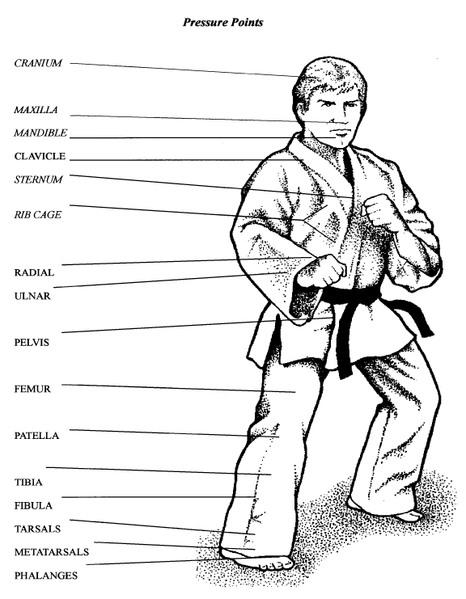
Accupuncture Meridian Points
